DISPLAY SCREEN EQUIPMENT REGULATIONS (DSE)
WORKSTATION ASSESSMENT –
SELF-ASSESSMENT QUESTIONNAIRE

USER = Return completed questionnaire to your line manager. Please also complete the Trust on-line DSE Training.

MANAGER = Review completed questionnaire, discuss results with user and where necessary seek advice and make adjustments. If necessary consult with the Trust Back Care Advisor or Manual Handling Team.

SENIOR MEMBER OF STAFF/ MANAGER = Implement any actions / recommendations and maintain appropriate records

Name:

Job Title:

Care Group/
Department:

Signature:

Date:
N.B. If you work at more than one workstation / agile working environment you must complete a questionnaire for each workstation.)

1. GENERAL:

GUIDANCE:
The definition of a display screen user is an employee who habitually uses display screen equipment for the purpose of an employer’s undertaking as a significant part of their normal employment. This includes anyone who uses display screen equipment either (a) for prolonged periods of more than one hour on most working days or (b) for shorter periods totalling two or more hours on most working days.

On average how many hours do you normally spend working on a PC at work each day?

Less than 1 hour each day
1-2 hours each day
2-3 hours each day
More than 3 hours a day

GUIDANCE:
Due to pain and discomfort caused by poor ergonomics and posture that is related to cumulative use, it is essential that the Trust determine the use outside the normal working environment. This can be either work related or leisure use, it is important that sound ergonomics and good posture are maintained when using DSE outside your normal working environment.

On average how many hours each day do you normally spend working on a PC away from your usual work environment?

Less than 1 hour
1-2 hours
2-3 hours
More than 3 hours

2. WORK CHAIR

GUIDANCE:
The height of your chair must be adjustable and the back of the chair adjusted to provide support for your lower back- the lumber region.

Do you regard the chair provided for your use as:

Stable? Yes No
Comfortable? Yes No
Can the following be adjusted sufficiently for your needs?

Seat height? Yes No
Seat back height? Yes No
Seat back angle/tilt? Yes No
Do you know how to make the above adjustments?
Yes No

Can your feet be placed flat on the floor?
Yes No

GUIDANCE:
If your feet are not flat on the floor when typing, you may require a footrest. High heels can affect posture. It is recommended that where long periods of DSE use take place flat shoes should be worn. Alternatively remove your shoes.
Do you require a footrest? Yes No

GUIDANCE:

Adjustment to the chair may be required and/or provision of a footrest. If you are experiencing any pain/discomfort report this to your manager who will refer you to Occupational Health through your HR advisor

When you sit on your chair at your desk, are the backs of your thighs and knees free of excess pressure?
Yes No

3. DISPLAY SCREEN

GUIDANCE:
Display Screen Equipment can be defined as any conventional cathode ray tube, screen and other display screen processes such as liquid crystal display. Display screens should not flicker. If it does, and this cannot be cured by a simple adjustment of the colour scheme or brightness/contrast controls, contact IT for further advice.

Does the Display Screen have a stable image with no flickering?
Yes No

GUIDANCE:
The screen should be adjusted so that the print is clear, but the contrast with the background is not so great that it causes glare.

Are you able to adjust the brightness and contrast between the characters and the background?
Yes No

GUIDANCE:
Make sure there is a comfortable viewing distance between your eyes and the screen and have some space between the keyboard and the front of the desk. You may need to move your desk away from the wall (or the desk opposite) to get the monitor far enough back. Place the screen in front of you so that you face it without twisting your body. Ensure any drawers under the desk do not obstruct your legs. If your PC is occupying too much desk space, if possible to do so move it off the desk. A flat screen may be of benefit to you if you are short of space on your desk.

Can you read the display screen comfortably?
Yes No

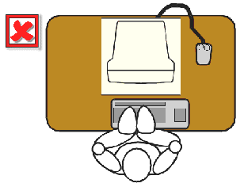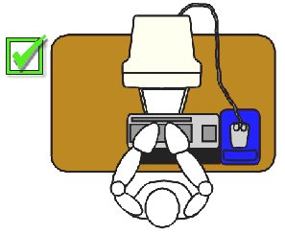

GUIDANCE:
Ideally the screen should be directly in front of you; about an arms length away; and should be sited so that you are looking slightly down towards the monitor.

Can the display screen be swivelled and tilted to reach a comfortable position without having to look down excessively?
Yes No

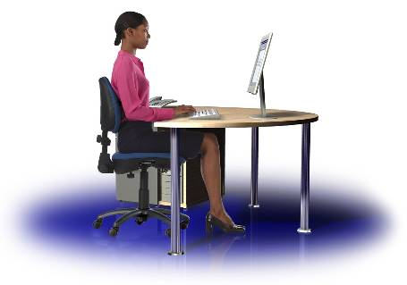
GUIDANCE:
The Screen should be clean and free from reflected light. The adverse effects of reflected light can easily be countered by turning the screen down/away from light sources. The ideal situation is where the screen is positioned at right angles to the window and very slightly upwards towards your eyes. Adjustable blinds may help in some cases. As a last resort an anti-glare/anti-reflection screen filter may be required.

Is the screen free from glare and reflection?
Yes No

Is the keyboard in good working condition?
Yes No

Is the keyboard adjustable for angle?
Yes No

GUIDANCE:
Keyboards should be separate from the display screen so that they can be located in a position on the work surface that is comfortable to you.

Is the keyboard detachable from the screen?
Yes No

GUIDANCE:
The keys on the keyboard should ideally be non-reflective and they should be kept clean, so that all the letters etc. can be read easily.

Does the keyboard have a matt surface?
Yes No

Are the symbols on the keyboard legible?
Yes No

GUIDANCE:
Unless the keyboard has a built in hand/wrist rest along its front edge, it should be located away from the front edge of the workstation so that the wrist of the hand can rest on the work surface.

Is there adequate space in front of the keyboard to provide support for your wrists?
Yes No

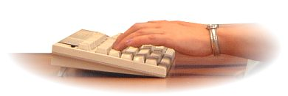

GUIDANCE:
If the keyboard is of a depth that you are finding it uncomfortable, you may need to have a separate hand/wrist rest.

Do you require a wrist rest?
Yes No
4. MOUSE

GUIDANCE:
When you are using the mouse, your upper arm should hang comfortably from your side and your forearm should be parallel to the floor. In this way the bottom of the mouse is aligned horizontally with your elbow. Keep the mouse as close to the keyboard as possible to avoid reaching, and so your arm is positioned consistent with the above description.

Is the mouse located in a comfortable position?
Yes No

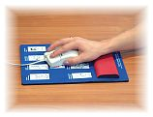

GUIDANCE:
A mouse mat should always be provided, if not speak to your departmental manager/supervisor.
Is a mouse mat provided?
Yes No

GUIDANCE:
The mouse should move freely across the mouse mat and the pointer should glide easily across the screen. If not your mouse may need cleaning or replacing.

Does the mouse move freely across the mouse mat?
Yes No

Does the pointer move smoothly across the screen?
Yes No

5. WORK DESK

GUIDANCE:
There should be sufficient space on the work desk arrangements to accommodate the display screen and clerical activities. Please Note: All office furniture purchased through purchasing will comply with the DSE Regulations.

Does the work desk allow adequate room for flexibility for the arrangement of work equipment?
Yes No

GUIDANCE:
Ensure that the workstation surfaces are matt, if they are not they need to be treated, covered or replaced.

Is the work desk surface free from glare?
Yes No

GUIDANCE:
Arrange your desk layout to make best use of available space. Document management is very important. If you need to look at the keyboard when typing, the best place for the document holder is between the monitor and the keyboard. Remember that the computer is not the only tool in constant use and others (such as the telephone) should also be readily accessible without stretching or twisting. Use the mouse as close to the keyboard as possible.

Is the work equipment arranged so that extensive reaching/twisting is minimised?
Yes No
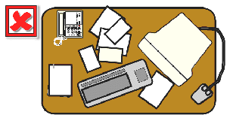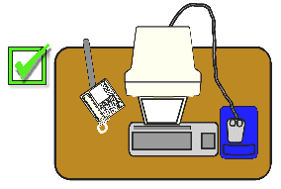

GUIDANCE:
Make sure that there are no obstructions, for example, boxes, cables etc. under the desk that prevent you obtaining a suitable position.

Is the underneath of your desk clear of obstructions?
Yes No

GUIDANCE:
There should be adequate space under the desk to provide appropriate leg room.

Is there adequate leg room underneath your desk?
Yes No

6. DOCUMENT HOLDER

GUIDANCE:
Document Holders allow documents to be positioned alongside between the key board and computer, paper on a clip board also works well and at the same height and distance from you, as the screen. They can be useful if you copy type frequently, and if you experience difficulty in refocusing your eyes when switching from the screen to the document.

Do you require a document holder?
Yes No

7. LAPTOP USERS

GUIDANCE:
If the laptop is your main computer and you use it for long periods it is advisable that you use a separate keyboard and mouse where available. The laptop should be on a firm surface and at the right height for typing. The use of a good working surface, separate keyboard and mouse will minimise the risk of pain and discomfort.

Is the laptop your main computer?
Yes No

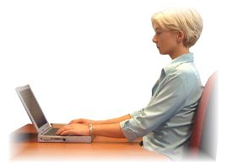
Follow this link for advice on posture when using a lap top computer or sitting on a couch. https://www.youtube.com/watch?v=PZWSc5EWDoA

Do you use a separate keyboard when using the laptop for long periods?
Yes No

Do you use a separate mouse when using the laptop for long periods?
Yes No

Is there a space in front of your keyboard to support your wrists?
Yes No

Is the laptop on a firm and level surface and at a comfortable height for typing?
Yes No

Do you use a desk top computer if it is available?
Yes No

8. NOTEBOOKS and other PORTABLE DEVICES

How often do you use your tablet/portable device continuously on a daily basis?
Less than twenty minutes More than twenty minutes

What are you using this device for?
E-mail Web browsing Other please state

When reading, can you use a stand?
Yes No

When typing can it be used horizontally?
Yes No

Do you use a separate keyboard?
Yes No

Do you use a separate mouse?
Yes No

Is there a space in front of your keyboard to support your wrists?
Yes No

Do you use a desk top computer if it is available?
Yes No

9. POSTURE

Are your forearms approximately horizontal when typing?
Yes No

GUIDANCE:
Your wrists and forearms should be extended with the minimum amount of bending and twisting. Regular changes in activity are recommended. If this is not possible build in suitable rest pauses to prevent the onset of pain and discomfort.

All tasks can also be subject to analysis against the Rapid Entire Body Assessment (REBA) score - an evidence-based assessment tool for the hierarchy of the REBA - The higher the score the higher the REBA:

- 8 Tuff book in car
- 6 Tuff book at dining table
- 6 Tuff book on a settee
- 3 Chair with lap top cushion.

Staff who come through the workplace assessment route may need to prioritise their working pattern down to the lowest risk possible. It is good to take a balanced risk approach. Further information / advice can be obtained from the Trust’s Manual Handling Team.

Do you move your wrists as little as possible when typing?
Yes No

Can you view the screen without turning your head?
Yes No

Are your eyes level with the top of the screen?
Yes No

10. WORK ENVIRONMENT

GUIDANCE:
Your workstation must have adequate space and flexibility to allow you to change position and vary movements.
Do you have sufficient space at your workstation to change position or vary movements?
Yes No

GUIDANCE:
The overall lighting level in your work environment should be not too bright that it makes the information on the screen difficult to read (causing eye discomfort, headaches etc.) and not too low that non-display screen work is difficult.

Is the lighting adequate for you to complete your work?
Yes No

GUIDANCE:
Ensure that the workstation surfaces are matt, and where necessary anti-glare screens should be provided and windows fitted with blinds.

Is it free from glare or distracting reflections?
Yes No

GUIDANCE:
Computers generate small amounts of dry heat, which can cause problems if there is insufficient ventilation. Ideally temperatures should be within the range 16C to 23C (61F to 73F), and the humidity levels should range between 40% to 60%. However, these are only guidelines and not statutory requirements.

Is the temperature and humidity comfortable?
Yes No

11. ORGANISATION OF WORK

Do you make time for adequate pauses / breaks to prevent discomfort in your hand, wrist and arm?
Yes No

GUIDANCE:
To avoid unnecessary stress and fatigue, you should try to mix display screen/ keyboard work with other work wherever possible.

Do you take rest pauses when using a display screen?
Yes No

Do you have a flexible work pattern where you can work on other tasks between using the display screen?
Yes No

12. NATURE OF WORK

GUIDANCE:
If you work from home on a regular basis using DSE it is important that sound ergonomic principles are used in your work environment.

Do you work from home on a regular basis?
Yes No

GUIDANCE:
The software should be suitable fast enough and user friendly for the particular job that you do.

Is the software you use suitable for the task?
Yes No

13. PERSONAL INFORMATION

Do you use specialist equipment for display screen use?
Yes No

Do you experience visual discomfort (e.g. visual fatigue) during or after using display screen equipment?
Yes No

GUIDANCE:
One of the risks associated with DSE use is work related upper limb disorder (WRULD). It is pain and discomfort experienced in the fingers, hands, wrists, arms, neck and back. It is important that if you do experience any of these report it to your manager or identify it here in this questionnaire.
Do you experience physical discomfort during or after using display screen equipment?
Yes No
GUIDANCE:
The Trust has appointed an Occupational Health Service Provider to advise on any aspect of work-related ill health. This includes any pain/discomfort associated with DSE use and a referral will be made to Occupational Health via your manager / HR advisor. If you do experience any pain/discomfort complete a Trust Incident Report IR1 form. Occupational health will undertake a more detailed assessment of your ill health associated with DSE work and provide a detailed report for your manager / HR.

Do you know how to report ill-health related to display screen equipment use?
Yes No

GUIDANCE:
If you are classified a ‘User’, you are entitled to a free eye test. The Trust will make a contribution payment for corrective eyewear under the DSE regulations. Your manager has the responsibility to pass your name onto HR who administer eye test payment.

Do you know how to obtain a free eyesight test?
Yes No

