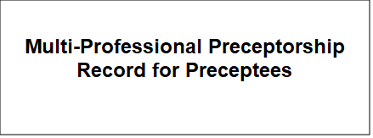

Activity | Proposed Date of Completion | Plan Agreed | Preceptee  Sign/Date | Preceptor/Clinician  Sign/Date | Completed | Preceptee  Sign/Date | Preceptor/Clinician  Sign/Date
RDaSH Induction
Local Induction
Mandatory Training
- ILS
- Moving and Handling
- PMVA
4)(add any other that is applicable to your role)
Skills Essential to Role
1))(add any that are applicable to your role)
E Learning agreed as applicable to role

