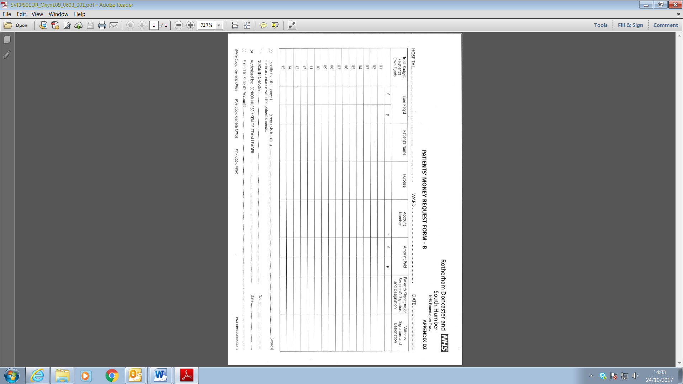

**Appendix G**

[](http://nww.intranet.rdash.nhs.uk/home/corporate-templates/rotherham-doncaster-and-south-humber-nhs-foundation-trust-rgb-blue/)