PROMPTS FOR CLINICAL SUPERVISION/SAFEGUARDING DISCUSSION

This prompt sheet has been designed as a way of supporting & structuring your clinical/safeguarding supervision discussion, please use if you feel this would be helpful to you.

The following are additional questions for clinical colleagues only:

SUPERVISORS WHAT THEORETICAL MODEL WILL YOU BE USING? e.g., Gibbs model of reflection
Gibbs (1988) model of Reflection
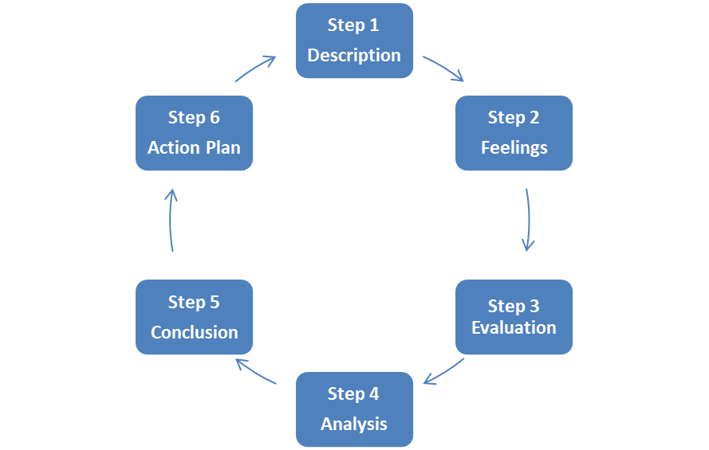
Theoretical model we will use:
CASE DISCUSSION
Think about what you would like to gain from this supervision session and how it can best support you.

Do you have any specific cases / work in mind that you would like to discuss?

How are you managing your caseload / workload at the moment?
Are you working with any challenging patients/families?
Are there any particularly challenging cases you’d like to speak about?

Are there any interventions where you feel you’d benefit from further improvement / gaining entry skills?
Are there any cases you’d like to discuss in relation to length of time on your caseload / workload / in service?
Would you like to discuss a patient / family’s goal, what it may be and how to support them reach it?
Where would they like to get to as part of their care / recovery? What interventions are being offered?

What is the care and treatment plan for the case(s) discussed? (long term / end goal)
RISKS / COMPLEXITY
This section is to reflect around any risks with complexity there may be on any cases you hold…
What is the complexity?
Is there any previous history that needs to be taken into consideration?
How are you finding managing this complex case(s)?
Have you experienced any difficulties where practice has changed because of the complexity & risk?
Have you reviewed risk assessment evidence of coproduction?
REFLECTION / SAFEGUARDING
What has worked well?
What hasn’t worked so well?
What needs to happen?
REVIEW CLINICAL RECORDS WITH SUPERVISOR
SUMMARY OF ACTIONS
Main reflections during this discussion and the next steps / actions are you going to take. (You may wish to refer to the Values and Behaviour Framework – Appendix 2).

