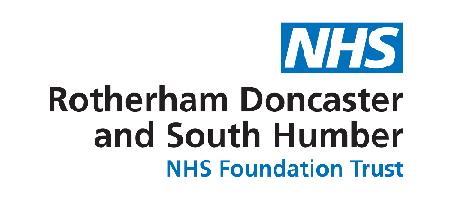
IG/ Data Protection Principles

- Personal data shall be processed fairly and lawfully
- Personal data must be obtained by fair means, in particular, the person from whom it is obtained must not be deceived or misled as to the purpose for which their data will be processed

- Personal data shall be obtained only for one or more specified and lawful purposes

- Personal data shall be adequate, relevant and not excessive in relation to the purpose(s) for which it was obtained

- Personal data shall be accurate and kept up to date

- Personal data shall not be kept for longer than is necessary for the purpose(s) for which it was obtained
- NHS organisations must follow the Records Management NHS Code of Practice

- Personal data shall be processed in accordance with the rights of the data subject, which include:
- Being able to view the data that an organisation holds on them, usually for a small fee
- Requesting that incorrect information be corrected
- Requiring that data is not used in any way that may potentially cause damage or distress
- Requiring that their data is not used for direct marketing purposes

- Appropriate technical and organisational measures shall be taken against unauthorised or unlawful processing of personal data and against accidental loss or destruction of or damage to personal data

- Personal data shall not be transferred to a country outside the European Economic Area unless that country ensures an adequate level of protection for the rights and freedoms of data subjects in relation to the processing of personal data

Declaration:

I agree to comply with the principles of the General Data Protection Regulations (GDPR) and the other guidelines I have been given relating to Information Governance

Signed ……………………………………………………….. Date..................

Please take a copy and return completed form to the Volunteers Office, Tickhill Road Hospital

