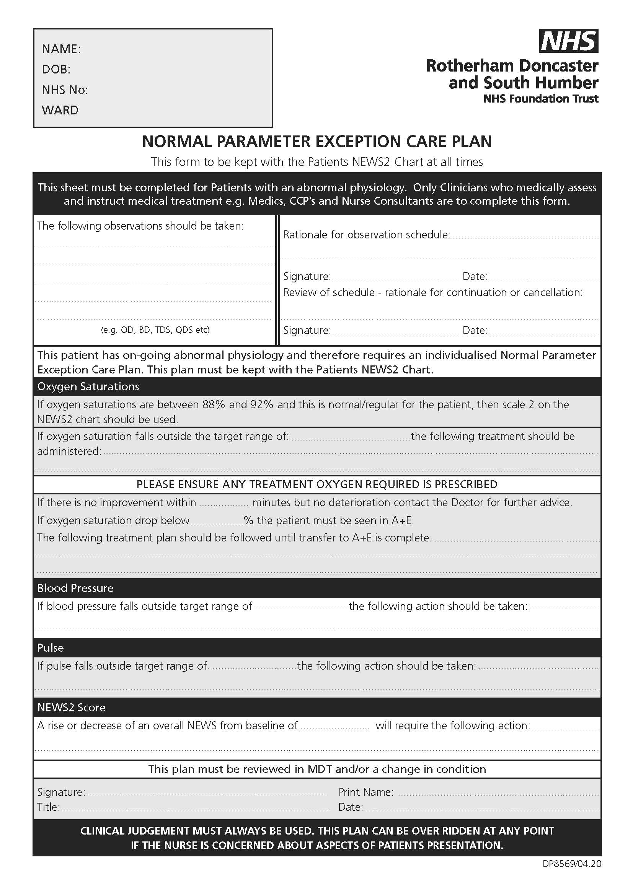

Appendix 2.3
Neurological Observation Chart – reorder information WZT720. Only use original documents.

This chart must not be photocopied

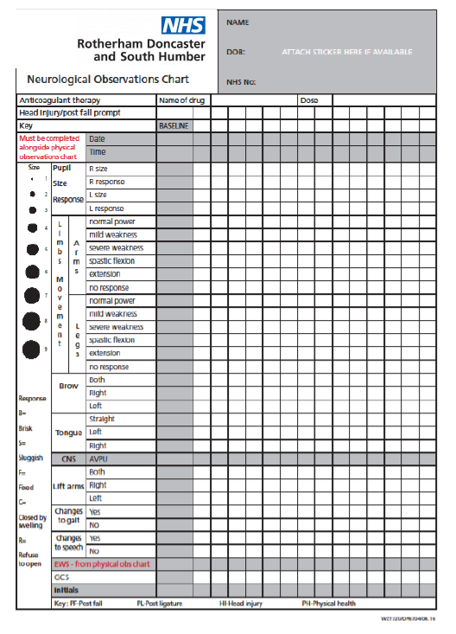
s (RCUK)

