**Appendix 3**

**Emergency Life Saving Drugs**

The provision of standardised medication to treat the deteriorating patient is vital; therefore all inpatient areas carry drugs that can be given in emergency situations by a Registered Nurse, these drugs will be kept in stock medication cupboards, easily accessible at all times, stored with the appropriate paraphernalia to administer and the appropriate flow chart displayed on the cupboard. These drugs are kept in orange/red containers within the drug cupboard (exception is glucagon which is kept in the fridge).

**These drugs are:**

Aspirin

Glyceryl trinitrate spray

Naloxone

Glucagon/Glucogel

Adrenaline

Oxygen

When an emergency lifesaving drug is administered the following details must be recorded in the patient records: date, time, drug name, strength, dose, route, batch number and expiry date along with the details of the patient’s presentation at the time of administration.

**See below for flow charts for administration**

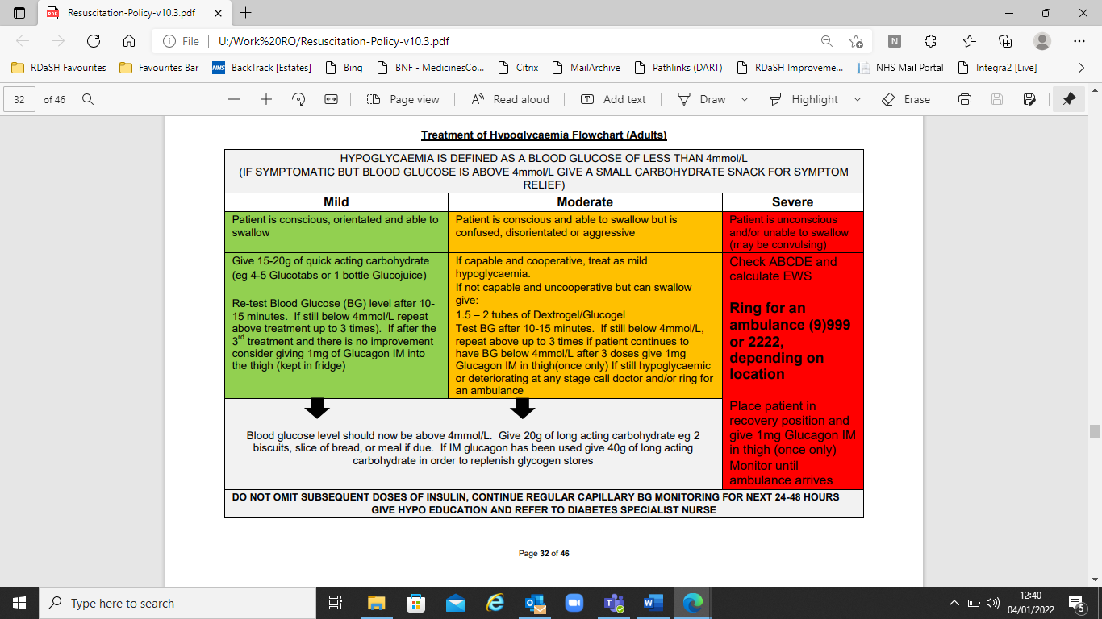

**Appendix 3.1**

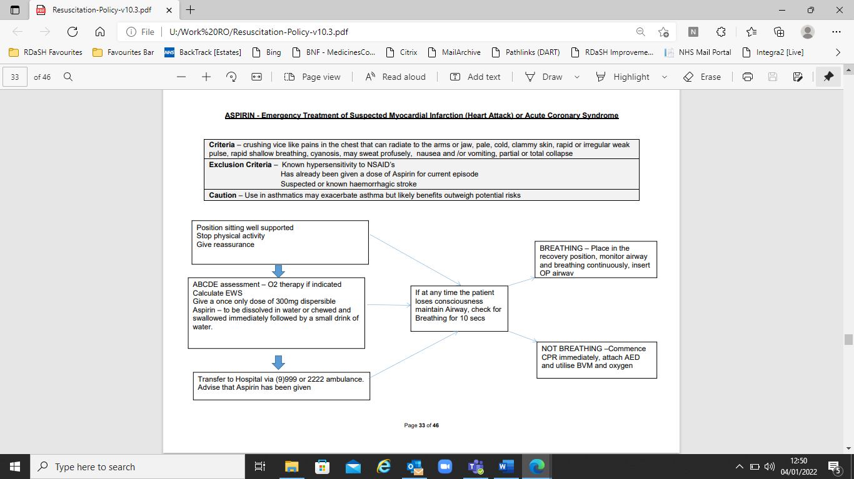

**Appendix 3.2**

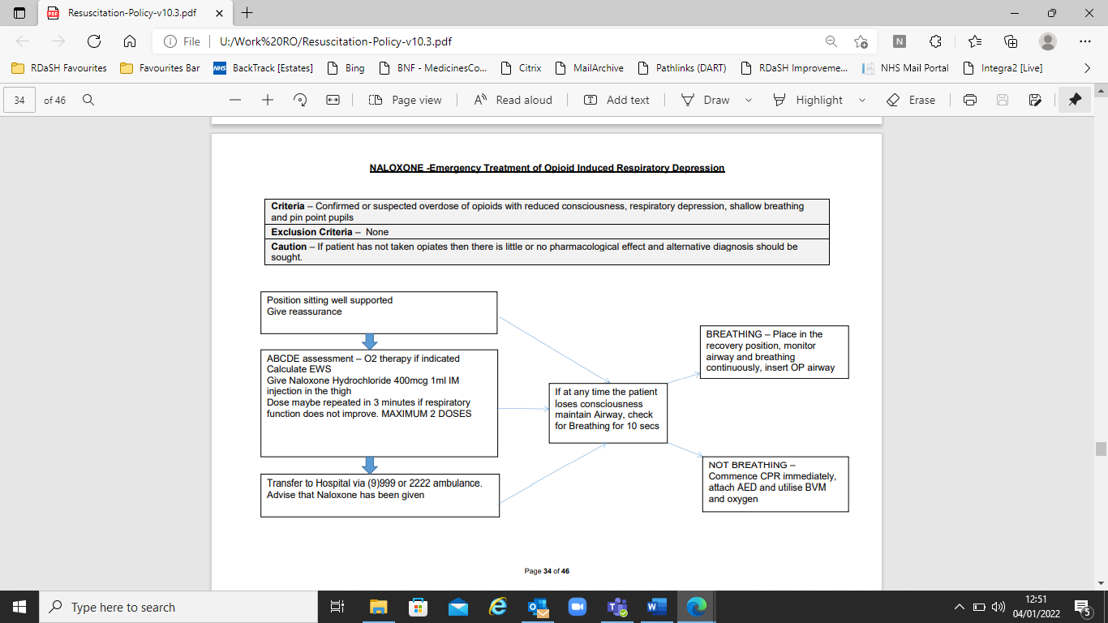

**Appendix 3.3**

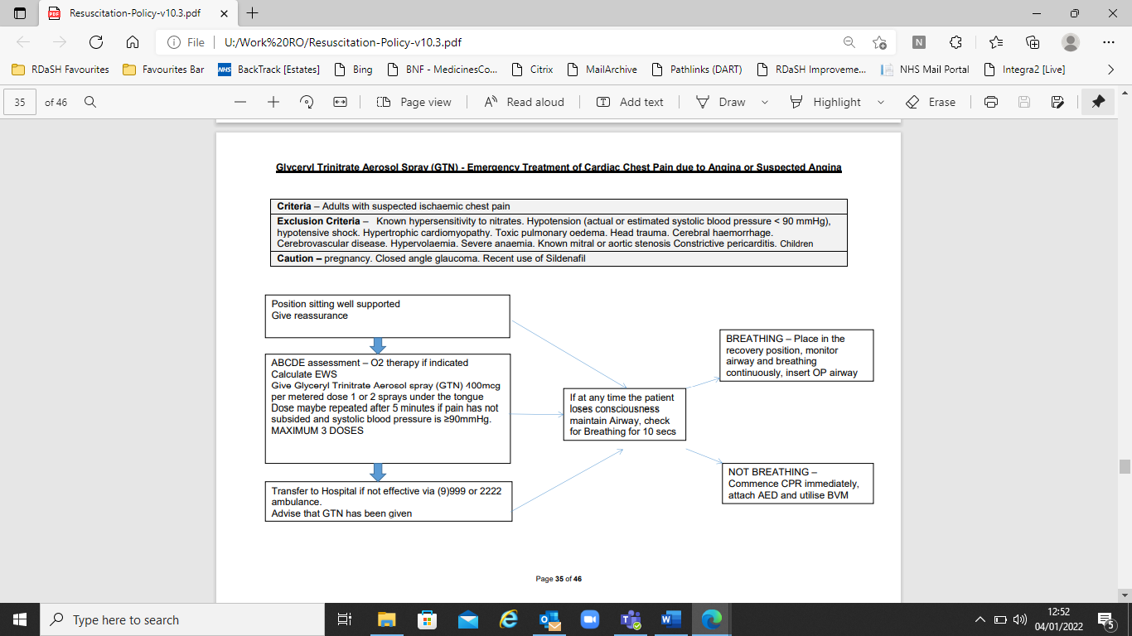

**Appendix 3.4**

For critically ill patients, high-concentration oxygen should be administered immediately (see the below flow chart), and this should be recorded afterwards in the patient’s health record.

**Symptoms which appear when the oxygen level is low include** fast pulse, rapid breathing, pale cold skin, sweating, lack of energy, cyanosis, headache, increased confusion, agitation or irritability, loss of coordination, loss of concentration, dizziness, blurred vision, and collapse.

**IF AN ACUTELY ILL OR COLLAPSED CASUALTY IS ABLE TO BREATH UNAIDED, THEN ADMINISTER HIGH CONCENTRATION OXYGEN TO IMPROVE THEIR CONDITION AND CHANCES OF SURVIVAL. THIS CAN BE ADMINISTERED BY A REGISTERED NURSE, DOCTOR, PARAMEDIC OR CLINICIAN WITHOUT PRESCRIPTION.**

Oxygen prescription for Acutely Hypoxaemic Patients

Is the patient critically ill or in a peri-arrest condition?

Administer 15L via non-rebreathing mask

**Yes**

**CALL 999**

Aim for a target saturation

of 88%-92%

Do they have COPD?

Administer for a maximum of 20 minutes. Remove oxygen and reassess the patient’s saturation levels.

h

**Yes**

Treat the hypoxia and administer 15L via non-rebreathing mask

If target saturations drop below the 88%-92% range

Resuscitation Council UK 2021

British Thoracic Society December 2019

Aim for a target saturation

of 94%-98%

**No**

If the patient’s saturations do not maintain/improve, administer a further 15L via non-rebreathing mask for another 20 minutes. Reassess and repeat every 20 minutes (there is no maximum time limit) until either patient improves or a medic/the ambulance service take over.

Oxygen should be discontinued once the patient can maintain saturation within or above the target range breathing air but the prescription for a target range should be left in place in case of future deterioration and to guide NEWS2.



**Appendix 3.5**

**INTRODUCTION**

* Allergic reactions and anaphylaxis are emergency conditions which are on the increase (1). It is well documented that the emergency treatment of anaphylaxis is more effective the earlier it is commenced (2) and may be life saving in the first few minutes.
* We must therefore be able to respond appropriately to this emergency.
* All in-patient units, and other services where a specific risk of severe allergic reaction has been identified, are required to stock/carry Adrenaline for use by suitably trained staff in an emergency situation.
* Adrenalin supplied on all appropriate inpatient areas and community staff. Community staff are supplied adrenalin packs from the pharmacy department
* It should be possible for a member of staff to move to another area and still be familiar with, and to be able to operate, the administration device quickly, therefore consistency in the administration device and method is required.

**STORAGE OF ADRENALINE**

* Adrenaline must be contained in a clearly marked container and kept in a secure location that is easily accessible and know to all members of staff, ampoules must be stored with needles and syringe in container to ensure swift administration.
* It does not require storage in a fridge but must be stored away from direct sunlight or places where temperature above 25ºC may be encountered.
* A system of checks must be put in place so that the adrenaline is replaced before the expiry date is reached. Adrenaline must be replaced if it appears to have become discoloured.

**LEGALITY OF ADMINISTRATION**

* The administration of adrenaline by staff to a person to save life is permissible by law (3) and does not require a prescription.
* If this action is taken, a full record of the incident must be made in the patient notes (if available) and the IR1 report of an adverse healthcare event.

**TRAINING**

* The administration of adrenaline is reasonably straight forward, but it does require a short training course which should be repeated each year.
* Training for anaphylaxis is via eLearning or face to face sessions arranged as the need arises. For areas with specific needs for anaphylaxis training a stand alone course can also be created as required. This is already provided for areas of the Trust who have hyper-allergic service users.

**ANAPHYLAXIS REFERENCES**

1. Sheikh & Alves, Hospital admissions for acute anaphylaxis: time trend study, BMJ 2000; 320; 1441

2. Resuscitation Council UK, Emergency Medical Treatment of Anaphylaxis for First Medical Responders and Community Nurses, RC (UK), Jan 2008, 3.1

3. Act of Parliament, Statutory Instrument 1997 No. 1830 The Prescription Only Medicines (Human Use) Order 1997, The Stationary Office Ltd., 1997

**Equipment**

The provision of suitable, standardised equipment is paramount in resuscitation so that staff are familiar, proficient and confident with the use of that equipment.

For areas revaluating the provision of resuscitation equipment within their areas the Trust emergency equipment risk assessment must be used in conjunction with discussions with the Resuscitation Officer.

Details are shown in Appendix 4 – Equipment Required in Healthcare Areas.

**Initiation Of, And Criteria For, Resuscitation**

All patients, visitors, and staff who collapse within the vicinity of Trust premises are to be resuscitated in line with this policy manual and procedures.

All patients being attended by a clinician, whether in hospital, healthcare unit or their own home, are to be actively resuscitated and suitable assistance called, unless they have a ‘Do not Attempt Cardio-Pulmonary Resuscitation’ (DNACPR) order in place, rigor mortis is present, or there are signs of decomposition. The temperature and pallor of the person’s skin should not be used as an indicator of the initiation of CPR.

In circumstances where staff think the casualty should have a DNACPR order, but does not, full resuscitation is to be attempted until an ambulance arrives and takes over, or a recognised doctor issues orders to stop resuscitation efforts.

On finding someone collapsed, staff should immediately assess the casualty, using the DRABC approach (check for **D**anger, check for **R**esponse, clear patients **A**irway, look listen and feel for **B**reathing, start chest **C**ompressions), and summon further assistance by initially shouting for help and activating any alarm systems in place. As soon as a medical emergency has been identified, then an ambulance will be summoned by:

**All areas within Tickhill Road Hospital and Tickhill Road Site**

Dialling - 2222 on the internal phone system, state cardiac arrest, the caller will be given instructions by switchboard staff to enable the call to be transferred to the Ambulance Service.

Great Oaks Dialling - 9-999

Woodlands Dialling - 9-999

Swallownest Court Dialling - 9-999

All other areas Dialling - 999

Softphone Dialling - 999