**Appendix 4**

**EMERGENCY EQUIPMENT**

The provision of suitable, standardised equipment is paramount in resuscitation so that staff are protected, proficient and comfortable with the use of equipment.

The provision of equipment can be split into three identifiable groups:

* Community In Patient units, including units where rapid tranquilisation, restraint or seclusion may be required.
* Staff working in the community and base points without patients
* Specialist areas which require individual consideration (e.g. ECT suites, longer term residential care units, etc.)

**1.1. Community Inpatient Units Including Units Where Restraint, Rapid**

**Tranquilisation or Seclusion Are Likely To Be Required.**

These units are supported by the ambulance service for advanced life support; therefore, **the emphasis is on basic life support and the early defibrillation of the casualty.** These units will require:

**‘Grab Bag’ containing:**

* Oxygen cylinder with flowmeter – ready for immediate use
* Oxygen tubing
* Bag, Valve mask resuscitator with oxygen reservoir, disposable single use
* High concentration non-rebreathing mask, disposable single use
* Oropharyngeal airways, size 3 and 4, disposable single use
* Protective gloves, four pairs, selection of sizes
* Pocket mask, disposable, single use
* Manual suction device
* Automatic External Defibrillator (AED) with;
* Single use razor single use
* Heavy duty scissors/shears suitable to cut clothing
* Wipes to dry chest (such as paper towels/gauze squares etc.)
* Spare electrodes

**Mechanical Suction unit with:**

* Rigid Catheter attached
* Disposable single use liners and tubing

The type and make of AED, suction and contents of the grab bag will be determined by the Resuscitation Officer to provide compatibility across the Trust.

The number and placement of equipment will depend on the size and layout of the

unit. The equipment should take **no longer than 3 minutes to get to the casualty.**

**Staff Working in the Community**

Staff may come across a collapsed casualty at any time; therefore they need to be

provided with equipment wherever they work. Clinical staff working in a base point or

out in the community require immediate access to:

* Pocket mask
* Protective gloves, non-latex, the users size

Therefore, clinical staff working away from a base point will be issued with a pocket

mask and gloves and must carry them at all times. Base points should have enough pocket masks to ensure availability within 3 minutes of a casualty ie in consultation rooms etc.

**Learning Disability Community Residential Units**

Due to a higher risk of choking incidents within the area of Learning Disabilities

manual suction is required within those areas: therefore these areas will have;

* Pocket mask
* Protective gloves, non-latex, various sizes
* Manual Suction device

The amount and placement of equipment will depend on the size and layout of the

home. The equipment should take **no longer than 3 minutes to get to the casualty.**

**However, a Learning Disability unit where physical restraint or rapid tranquilisation may be required will be required to have the same equipment as a Community Inpatient unit, section 1.1. This requirement will be identified by risk assessment.**

**Extra Equipment**

The use of other resuscitation equipment without a suitable training program and procedure may be dangerous for the casualty and/or rescuer. If any other equipment other than that specified above is felt to be required, it should be discussed with the Resuscitation Officer.

**Ligature Cutters**

All in-patient wards within mental health and learning disabilities should carry ligature

cutters.

1 cutter placed in the treatment room

1 cutter placed in the office

In wards with a 136 suite an additional ligature cutter will be kept in the 136 office. Three spare cutters will be kept in each area in the grab bag spares box. Each cutter

must only be used once and then sent to be sharpened, sanitised and serviced. At

this time the spare cutters should be rotated to ensure cover.

**ENSURING EQUIPMENT IS CHECKED, STOCKED AND FIT FOR USE**

Each ward/department should have systems in place so that:

* Resuscitation equipment appropriate for the area is present, available and suitably maintained, with accurate records maintained on the Medical Devices Inventory.
* Equipment is checked daily and weekly, by appropriate staff, in line with the manufacturer’s recommendations or local policy as required. A signed and dated record of these checks should be maintained and kept for 3 years (see appendix 6).
* Adequate stocks of disposable/single use parts of resuscitation equipment, such as pocket masks, oxygen masks, airway tubes, defibrillator pads etc. Must be held to enable continued functioning of the equipment.

After a resuscitation attempt, or an event where the resuscitation equipment is used, the person in charge of the ward/department at that time should check that the equipment is ready and available for another event as soon as practicable.

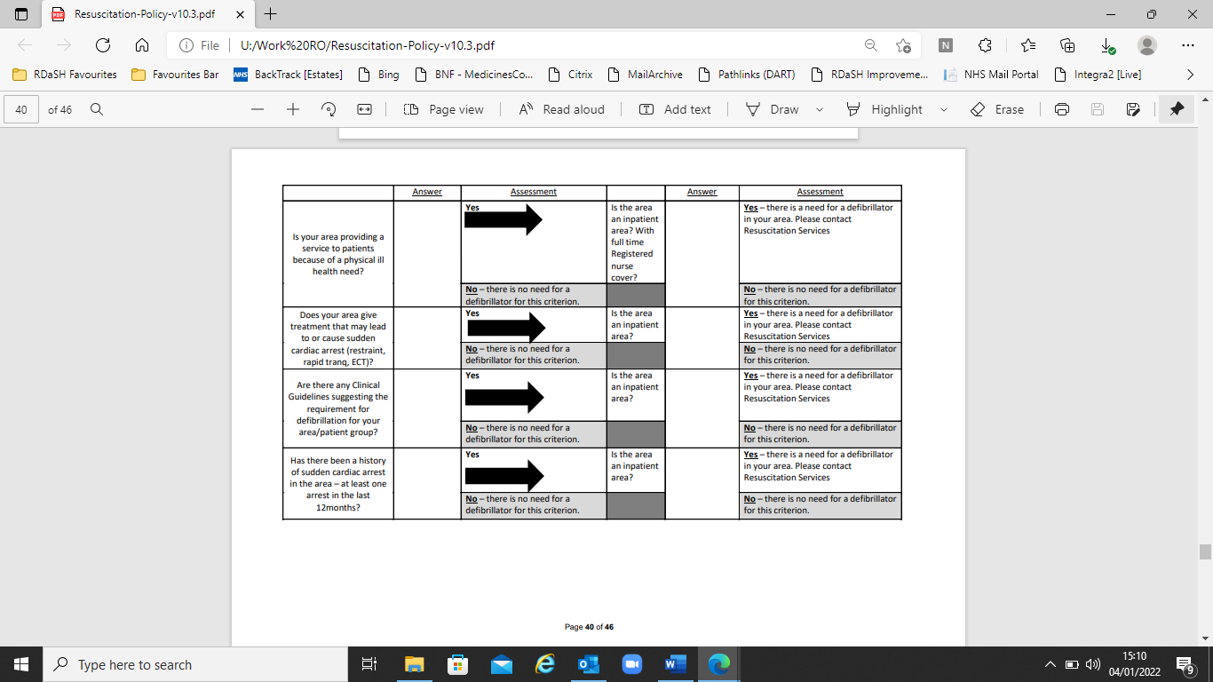

**EQUIPMENT CHECKLIST**

Each ward/department should have systems in place so that:

* Resuscitation equipment appropriate for the area is present, available and suitably maintained, with accurate records maintained on the Medical Devices Inventory.
* The Automatic Defibrillator is visually checked daily, in line with the manufacturers recommendations.
* All other emergency equipment is checked weekly, by appropriate staff, in line with the manufacturer’s recommendations and local policy as required. A signed and dated record of these checks should be maintained and kept for 3 years.
* Adequate stocks of disposable/single use parts of resuscitation equipment, such as pocket masks, oxygen masks, airway tubes, defibrillator pads etc. are held to enable continued functioning of the equipment.

After a resuscitation attempt, or an event where the resuscitation equipment is used, the person in charge of the ward/department at that time must check that the equipment is ready and available for another event as soon as practicable.

The Automatic defibrillator requires a visual check that it is functioning each day (or period of 24 hours), and once every week a more detailed check of the whole equipment.

How to do this is detailed on the checklist form.

These daily and the weekly checks are to be recorded on the checklist form on the next page.

Any concerns or issues are to be reported to the manager, or the Resuscitation Officer.

**Grab Bag Checklist**



## 

## Cardiac Arrest Incident Reporting, Including External Reporting Requirements

Allresuscitation attempts should be reported on the Trust Ulysses incident reporting system (IR1) AND by the completion of the Cardiac Arrest Report Form (see below) which must be received by the Resuscitation Officer within 24hrs of the incident.

ALLserious (life threatening) sudden medical emergencies, e.g. choking and anaphylaxis, and any emergency medical equipment failures should be reported using the Trust Ulysses incident reporting system (IR1).

Deaths should be reported on a mortality form on the Ulysses incident reporting system. If a death is deemed to be a Patient Safety Incident this will be reported to NHS Improvement through the National Reporting & Learning System, some deaths may be referred to the Coroner’s Office and certain deaths to the Care Quality Commission. Please see the [Incident Management Policy](https://www.rdash.nhs.uk/publications/incident-management-policy/) for details.